

Name | Mrs. KAVYA B K
Designation | Assistant Professor
Education Qualification | BE, MTech (CSE), (PhD) | 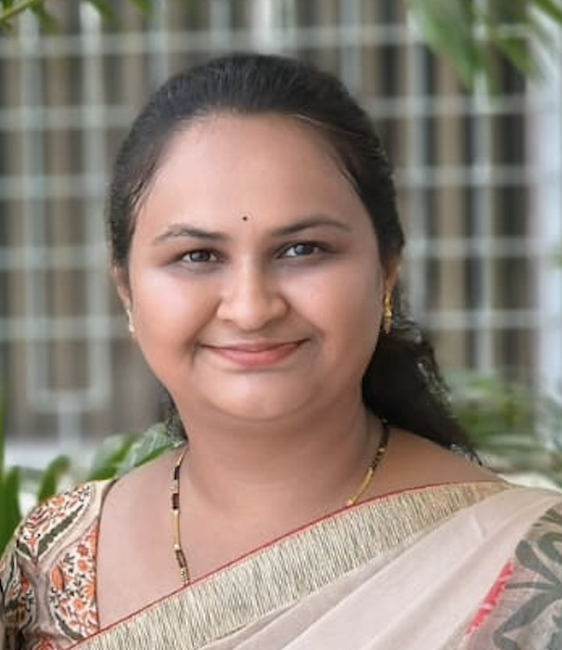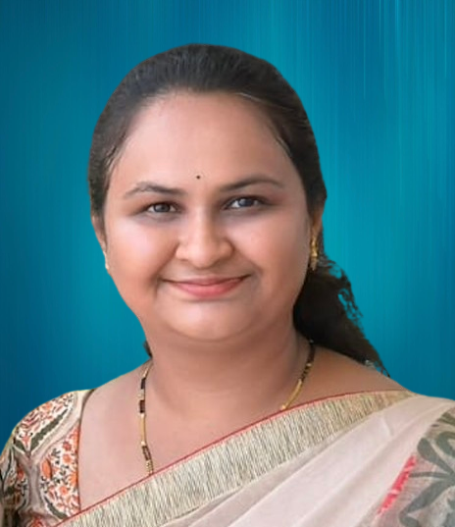
Experience | Teaching : 3 Years  Industry : 4 Years
Area of Interest | Natural Language Processing
Date of Joining @AIEMS | 13th Sept, 2022
Email ID | kavyabk07@gmail.com

List of Paper publications:

- A “Earthquake alert system by using IoT Technology” International Journal of Scientific Research in Engineering and Management (IJSREM) Impact factor 8.176, July 2023 | ISSN:2582-3930.

Conferences/Workshops/Conducted/Attended:
- Attended Five days “Emerhing Technologies” from 11th to 15th Dec 2023 at Vidyavardhaka College of ENgineering, Mysore.
- Attended Two days “National Symphosium” on 8th -9th Sept 2023 at BEC Bagakot.
- Conduted Two days workshop on “GIT Hub” on 25-04-2023 and 1-4-2023 at AIEMS, Bangalore.
- Conducted Three days Technical Training on “OOPS Concept” on 4, 11, 18th March 2023 at AIEMS, Bangalore.

